**Money Bingo**

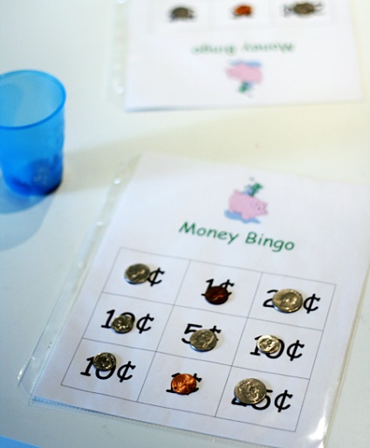Using Money Bingo cards, let students play bingo as you call out the cents values, or as you hold up the coins for them to see.

To play, you will need **a cup of coins** and some **bingo boards with coin values**.  You can make a couple boards with your child, or [**print ours**](http://lets-explore.net/blog/wp-content/uploads/2010/08/Money_Bingo.pdf) if you’d like. After each player has chosen a lucky board, **take turns picking a coin from the cup and placing it on the matching value.**

If you don’t have any more spaces for the coin you chose, put it back and lose a turn.  First person to get three-in-a-row says, “Bingo!”

We also like playing blackout, where the whole board has to be filled.